**Task No: 7. Utilizing ‘Functions’ concepts in Python Programming.**

**Aim:**

To write the python program using ‘Functions’ concepts in Python Programming

***7.1. You are developing a small Python script to analyze and manipulate a list of student grades for a class project. Write a Python program that satisfies the above requirements using the built-in functions print(), len(), type(), max(), min(), sorted(), reversed(), and range().***

**Algorithm:**

1. Start the program
2. Print a welcome message: Outputs a simple greeting.
3. Determine and print the number of students: Uses len() to find the number of elements in the student_names list.
4. Print the type of lists: Uses type() to show the type of the student_names and student_grades lists.
5. Find and print highest and lowest grades: Uses max() and min() to determine the highest and lowest values in student_grades.
6. Print sorted list of grades: Uses sorted() to sort the grades.
7. Print reversed list of grades: Uses reversed() to reverse the sorted list and converts it to a list.
8. Generate and print a range of grade indices: Uses range() to create a list of indices from 1 to the number of students.
9. Stop

**Program:**

def analyze_student_grades():

# Sample data

student_names = ["Alice", "Bob", "Charlie", "Diana"]

student_grades = [85, 92, 78, 90]

# 1. Print a welcome message

print("Welcome to the Student Grades Analyzer!\n")

# 2. Determine and print the number of students

num_students = len(student_names)

print("Number of students:", num_students)

# 3. Print the type of the student names list and the grades list

print("\nType of student_names list:", type(student_names))

print("Type of student_grades list:", type(student_grades))

# 4. Find and print the highest and lowest grade

highest_grade = max(student_grades)

lowest_grade = min(student_grades)

print("\nHighest grade:", highest_grade)

print("Lowest grade:", lowest_grade)

# 5. Print the list of grades sorted in ascending order

sorted_grades = sorted(student_grades)

print("\nSorted grades:", sorted_grades)

# 6. Print the list of grades in reverse order

reversed_grades = list(reversed(sorted_grades))

print("Reversed grades:", reversed_grades)

# 7. Generate and print a range of grade indices from 1 to the number of students

grade_indices = list(range(1, num_students + 1))

print("\nGrade indices from 1 to number of students:", grade_indices)

# Run the analysis

analyze_student_grades()

**Output:**

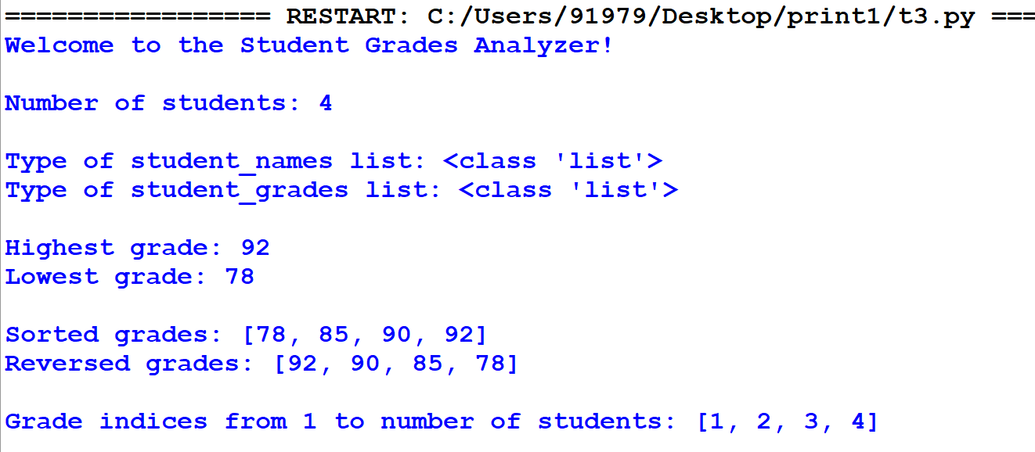

***7.2.* You are tasked with creating a small calculator application to help users perform basic arithmetic operations and greet them with a personalized message. Your application should perform the following tasks: addition, subtraction, multiplication, division.**

**Algorithm:**

1. Start the program
2. User Input for Numbers: The program prompts the user to enter two numbers.
3. User Input for Operation: The program prompts the user to choose an arithmetic operation (addition, subtraction, multiplication, division).
4. Perform Operation: Based on the user's choice, the program performs the chosen arithmetic operation using the defined functions.
5. Display Result: The program displays the result of the operation.
6. Stop

**7.2.Program:**

def add(a, b):

"""Return the sum of two numbers."""

return a + b

def subtract(a, b):

"""Return the difference between two numbers."""

return a - b

def multiply(a, b):

"""Return the product of two numbers."""

return a * b

def divide(a, b):

"""Return the quotient of two numbers. Handles division by zero."""

if b != 0:

return a / b

else:

return "Error: Division by zero"

def greet(name):

"""Return a greeting message for the user."""

return f"Hello, {name}! Welcome to the program."

def main():

# Demonstrating the use of user-defined functions

# Arithmetic operations

num1 = 10

num2 = 5

print("Arithmetic Operations:")

print(f"Sum of {num1} and {num2}:", add(num1, num2))

print(f"Difference between {num1} and {num2}:", subtract(num1, num2))

print(f"Product of {num1} and {num2}:", multiply(num1, num2))

print(f"Quotient of {num1} and {num2}:", divide(num1, num2)

# Greeting the user

user_name = "Alice"

print("\nGreeting:")

print(greet(user_name))

# Run the main function

if __name__ == "__main__":

main()

**Output:**

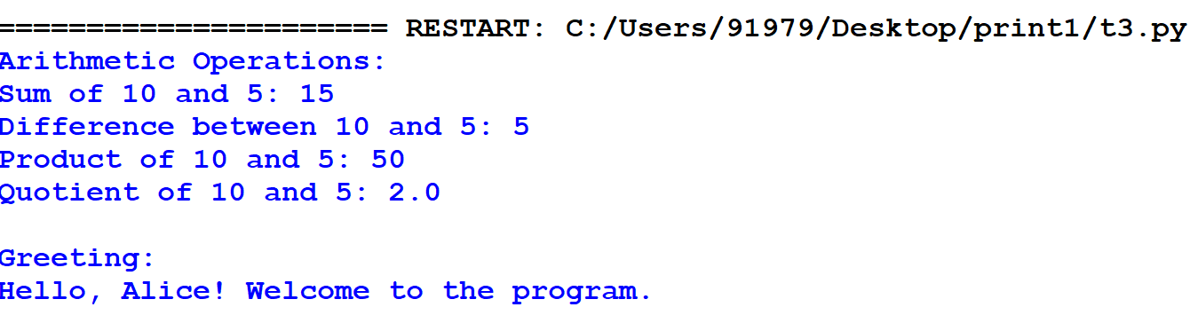

**Result:**

Thus, the python program using ‘Functions’ concepts was successfully executed and the output was verified.